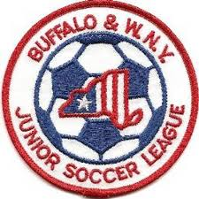Buffalo & Western New York
Junior Soccer League
Board of Directors Meeting
September 16, 2019
7:00 PM
Section I – General Matters

- Finance Reports –
a) Treasurer's Report – Neal S.
b) Worker’s Comp Update – Bob L.
c) Other Issues Outstanding (if any)
- Season Competition Reports
a) Schedules - Bob L.
b) Reschedules - Bob L.
c) Awards – Bob L.
c) Referee Report - John K.
- Odenbach Reports
- Website
- Renewal of Referee Assignment agreement
Section II – Governance Matters

- Appointment to fill Trustee Vacancy
- 2019 Board Member Terms Expiring – Vice President, Secretary, Trustee 1 (2 yr. term)
- Board Member Assignments for 2019-2020

Section III – General Policy Issues
- Non Member Clubs entering teams for League play
- U.S Club Soccer
- Lackawanna Club matters
- Policy & Procedure Revamp to match new website, operations
- Limit youngest age to April 30, 2012 (eliminate 7 y/o’s on the field)
- Offer U8 and U9 Divisions
- “Rolling” Registration Dates
- Number of Teams – Caps, limits on number per club or age group
- Fields needed to register teams
- Alignment Issues
- Roster Freeze Dates
- Reschedule Issues – Limit, eliminate
- Future of Dual Carding
- Pre-game Handshake vs. post game
Adjournment
Upcoming Board Meetings
October 28, 2019 December 2, 2019 January 20, 2020 March 30, 2020
Upcoming League Meetings
February 3, 2020 April 27, 2020 August 10, 2020 October 5, 2020 (AGM)

